User Manual

Search of Catalogue:

Basic Search Function:

Capture:
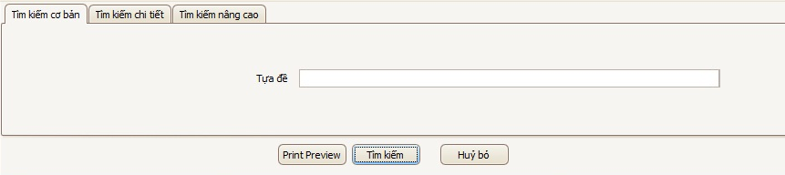

Purpose:
- This kind of function helps librarian search books quickly by using their titles.

Step by step:
- Typing the whole or one part of the title into textbox will be the first step.
- Click to activate the function.
- Searching results will be listed in the below grid-control. (View “List of Result” for more detail).
- If button is clicked, information in textbox will be erased.

Detail Search Function:

Capture:
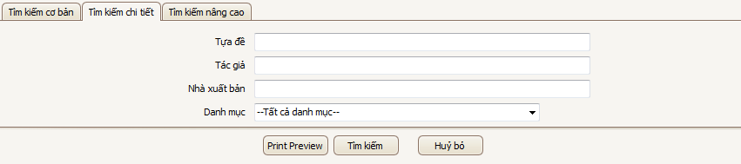

Purpose:

This feature supports users looking for a more detailed items based on the information of the title, author, publisher, or type of book lists

.Step by step:
- Users will enter search information into one or more of the input text boxes to get close to the search results most desired.
- Next, pick a book list that you belong to. If the list is selected as "All categories", the search results will include all the books in the book under the category of systems.
- Click to activate the function.
- Searching results will be listed in the below grid-control. (View “List of Result” for more detail).
- If button is clicked, information in textbox will be erased.

Advance Search Function:

Capture:
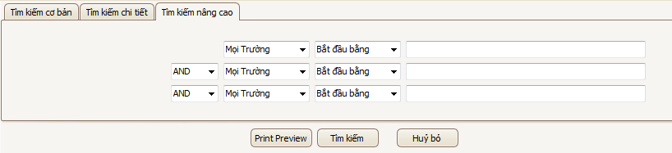

Purpose:

This is the search function the most detailed books of the system. It supportsuser searches in a row in many different fields of information and to book morethan two choices on the search function

.Notes:
- : three combo boxes lets you select one or many different information for your search
  - All cases: the system will find information on school policies, such as title, author, publisher, category, language ...
  - Book Title: find information on titles
Author: find detailed information on the author
  - Publisher: find information on publishers
  - Categories: find information based on categories
  - Languages​​: find detailed information on language
- : three combo box will be a choice about the type of search strings of users. There are four choices here, including:
  - Start with: the system will perform functions based on the search string begins with the user information input into the right-hand text boxes.
  - End with: the system will perform functions based on search string ends withthe user information input into the right-hand text boxes.
  - Found in: the system will perform functions based on search string containingthe user information input into the right-hand text boxes.
  - Accuracy: will execute system functions based on the search string exactly whatthe user enters the text boxes on the right input.
- : This is the way chosen to append the search string 2nd and 3rd in command of the search system. There are 3 choices, respectively: AND (And), OR (OR) andNOT (not included)
- After all input is three text boxes. The user can fill in one or more arbitrary text boxes. 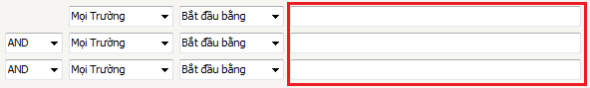

Step by step:
- The user will perform the function by entering into the third text boxes of the input required information.
- The corresponding value of the combo box to complete the search stringas you wish.
- Click to activate the function.
- Searching results will be listed in the below grid-control. (View “List of Result” for more detail).
- If button is clicked, information in textbox will be erased.

List of Result:

Capture:
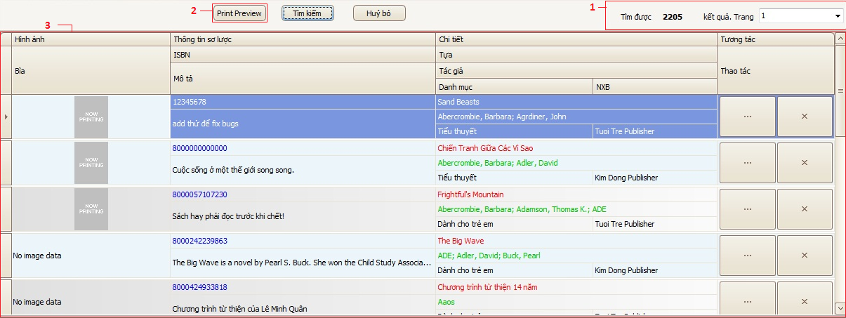

Notes:
- 1: This is where the total number of books display system found. Combo-Box helps users next to display the corresponding page titles (the system will automatically split page results found, top 10 books a page, if the number found is greater than 10).
- 2: This is a button to support the user to view the search results before printing.
- 3: This is a table showing most of the information systems found the book at the request of the user.

Rental Register Search Function:

Capture:
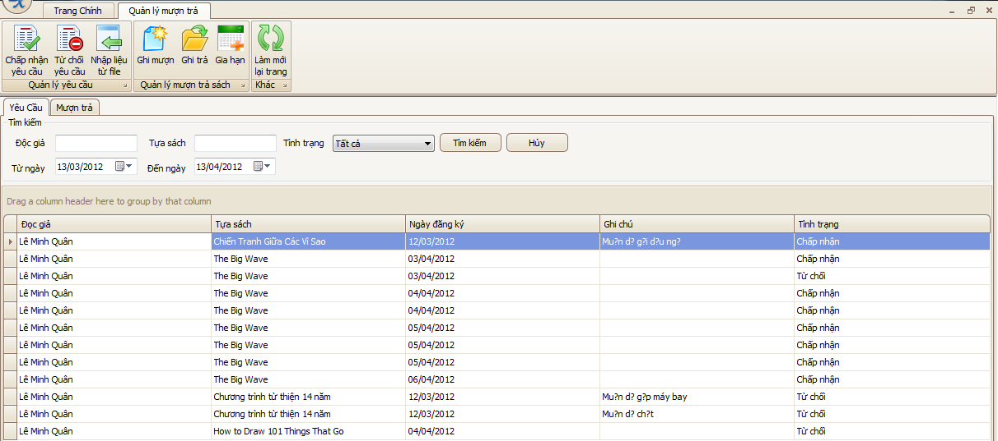

Step by Step:
- After opening the repayment Management screen, the user will select the tab"Request".
- There are two input text boxes, including "A Reader" and "Titles" to assist librarians who search by name or title registration borrow reserve books already.
- Just below the second text boxes and the date. The librarian will click on the second text boxes to select a time period of the registration requirements.
-  Right is the combo-box allows selection of the state librarian's request should belooking for. There are three states of "New", "Accepted", "Deny". Also if the user selects "All", the system will find the requirements for all states.
- Click to activate the function.
- If button is clicked, information in textbox will be erased.

Rental Detail Search Function:

Capture:
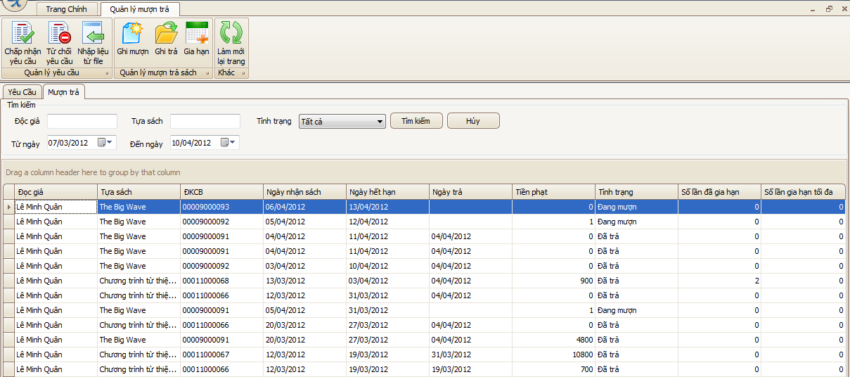

Step by Step:
- Also at repayment Management screen, users will need to switch to tab "Borrowing to pay" to perform this operation.
- The steps are similar to search function register borrow books, besides the twofollowing points:
  - Two text boxes received date will be filtered by date, but that details on the loanpayment systems.
  -  Status details of the "Borrowing to pay" are three states: "Being on loan", "paid"and "Lost."

Users Search Function:

Capture:

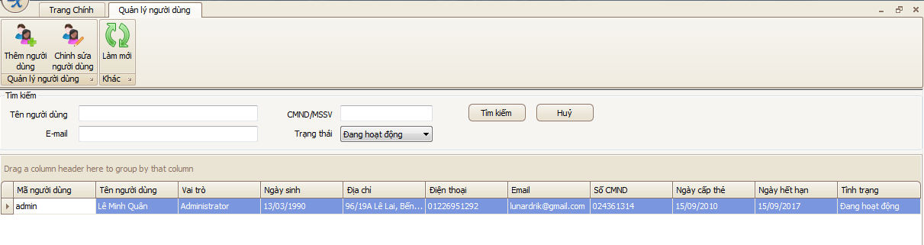

Step by Step:
- After the opening screen to manage users, users will see the text boxes combo-box to enter and search support.
- The input text boxes as , and get user information entered from the keyboard on the system's user name,identity card number (ID) or Student Identification Number (student ID) of the user...
- this is the user's state is saved in the system. There are two main status "In operation" and "Block".
- Click to activate the function. Results will be listed in the below grid-control.
- If button is clicked, information in textbox will be erased.

